Chapter 19, Solution 82

We follow Example 19.15.

(a) Set V₂ = 0 and I₁ = 1A. The schematic is shown below. After simulation, we obtain

h₁₁ = V₁/1 = 3.8, h₂₁ = I₂/1 = 3.6

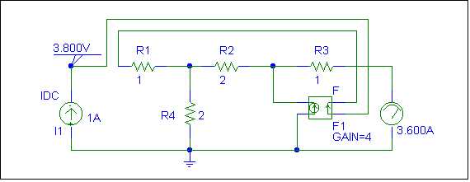

(b) Set V₁ = 1 V and I₁ = 0. The schematic is shown below. After simulation, we obtain

h₁₂ = V₁/1 = 0.4, h₂₂ = I₂/1 = 0.25

Hence, [h] =

